Canopy Summer Camp Registration 2013
Trapeze, Hoop Dance, Art, Storytelling, and Creative Movement

June 3th - July 29th, Monday-Friday 9:00am-12:00pm

Kindergarten - 5th grades (as of fall 2013) + Camp for Middle and High School

Cost: $260/two weeks and $175/one week
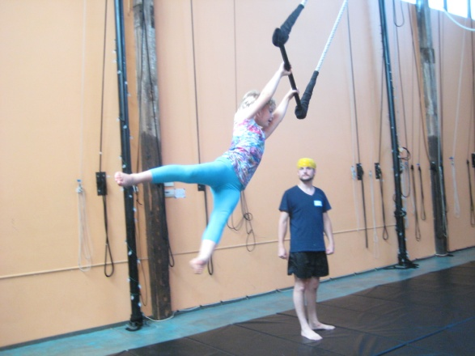 |  |  | 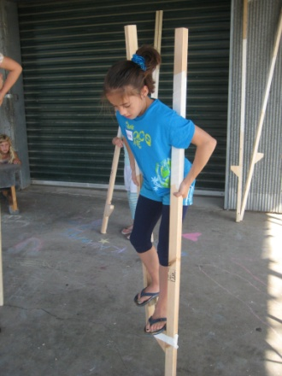

Camper Name (please print)___________________________________________

Age of child summer 2013 / Grade as of Fall 2013: Age__________/ Grade _________

Parent / Guardian Name:__________________________________________

Phone #_________________________ ______________________________
Email: _____________________________________________________________________

Mailing Address ___________________________________________________________

Check all that apply:

First time Campers K-5th ____ June 3-7
Mixed Levels K-5th ____ June 10-14
____ June 17-21
____ June 24-28
____ July 8-12
Beginner/Intermediate 5th-8th grade ____ July 15-19
Advanced 5th-High School, _____ July 22-26 Approval required ann@canopystudio.com
Invented Equipment 2nd- 6th _____ July 29- Aug 2 two years trap experience required, email Ann

Tell us about your camper:
Current hobbies & physical activities/experience:

Activities of interest in Canopy camp:

Returning student?: How did you learn about us?

Need more information? Email ann@canopystudio.com for information regarding summer programming.
To hold your child’s space, please mail this registration form and a 50% deposit to:
Canopy Studio * 160-6 Tracy Street * Athens, GA 30601

